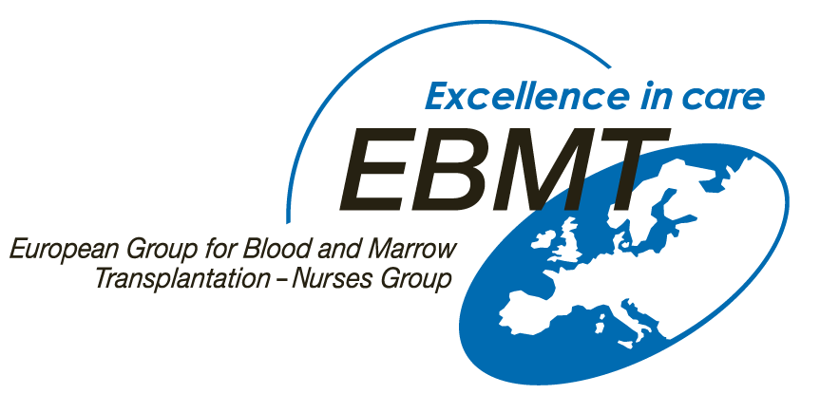

EBMT Nurses Group
CML Learning Programme Evaluation Form

Gaining your feedback on this Learning Programme is very important to the EBMT Nurses Group, in order that future educational initiatives can directly meet the educational need of nurses and other allied health care professionals working in the field of haematology / oncology.

First Name: Last Name:
Job title: Organisation or hospital:
City: Country:
Email:

Please complete the evaluation form:

The quality of presentations were: | □ excellent | □ good | □ fair | □ poor | comments:
The quality of the case studies were: | □ excellent | □ good | □ fair | □ poor | comments:
How informative did you find this  CML Learning Programme: | □ very useful | □ quite useful | □ of limited use | □ not useful | comments:
How would you rate this CML  Learning Programme overall? | □ excellent | □ good | □ fair | □ poor | comments:
Will you sue this module to  explain / educate others? | □ yes | □ no
If YES: | □ Nurses | □ Students | □ Patients | □ Physicians

What are the most significant new things you have learnt from this programme?

Comments; please include aspects that you would like to see improved, or what topics would you like to see in future presentations?

Thank you for your feedback!
Validation:

I certify that I have studied the CML Learning Programme and have personally completed this form.

This evaluation form should be send to erik.aerts@usz.ch in exchange for the EBMT Nurses Group CML Learning certificate.

