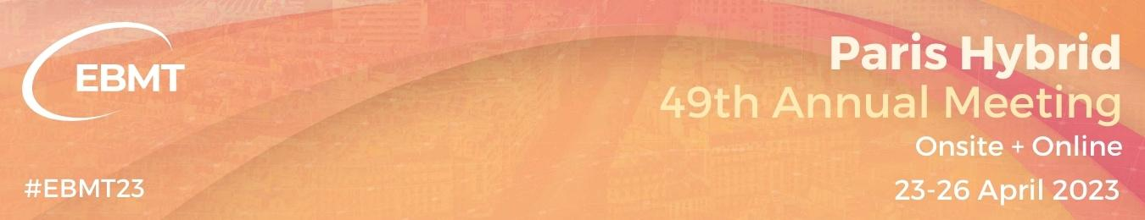
Quote request 2023: Host ⬥ Hostess ⬥ Barman

IF YOU WANT TO BOOK OUR RECEPTION STAFF
(Thank you for filling in the following informations)

Your quote request should be sent to : tmaudez@cityone.fr

Informations :
Company :
Address:
Zip :
City :
Sales Contact : Staff requirement:
Phone number : Host/Hostess :
E-mail : Barman :
Invoice informations (Address and Name) : Other:
Intra-Community VAT Number:

Time schedule:

DATE | STAFF PROFILE | Number of Staff needed | Where:  Booth Nº / meeting room Nº / symposium room Nº | Task to do | Starting Time | End Time
 | Choose from:
 | Choose from:
 | Choose from:
 | Choose from:
 | Choose from:
 | Choose from:
 | Choose from:
 | Choose from:
 | Choose from:
 | Choose from:
 | Choose from:

NOTE: Minimum contracting 3h

