Declaration

On behalf of Wilkens Medical Translations, the undersigned certifies that the Italian translations with our reference WI21-000038:

- EBMT-F-023-01 PIL and ICF for Sharing Data with the EBMT and collaboration partners_14-17 yr_Master_EN_Version 1.0_08Jul2020_Italy_FNL-ita-IT
- EBMT-F-023-01 PIL and ICF for Sharing Data with the EBMT and EBMT collaboration partners_parents_Master_EN_Version 1.0_08Jul2020_FNL-ita-IT
- EBMT-F-023-01 PIL for Sharing Data with the EBMT and collaboration partners_children 7-13 yr_Master_EN_Version 1.0_08Jul2020_Italy_FNL-ita-IT

are true and full translation of the original English documents:

- EBMT-F-023-01 PIL and ICF for Sharing Data with the EBMT and collaboration partners_14-17 yr_Master_EN_Version 1.0_08Jul2020_Italy_FNL
- EBMT-F-023-01 PIL and ICF for Sharing Data with the EBMT and EBMT collaboration partners_parents_Master_EN_Version 1.0_08Jul2020_FNL
- EBMT-F-023-01 PIL for Sharing Data with the EBMT and collaboration partners_children 7-13 yr_Master_EN_Version 1.0_08Jul2020_Italy_FNL

The translation is performed by a native speaker of the target language. In addition, a reviser has carefully proofread the translations for accuracy, completeness, use of the correct medical terms, correct reproduction of the source text, as well as spelling and grammar. This reviser is either a native speaker of the target language, or has a linguistic degree in the target language.

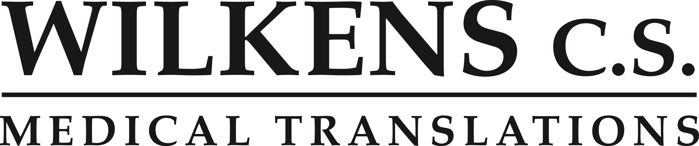Leiden, 14 January 2021

Postbus 611 2300AP Leiden (NL) T: +31 (0)71 581 12 11 E: info@medicaltranslations.nl I: www.wilkens.nl K.v.K.: 28058877 BTW: NL801767635B01 IBAN NL04ABNA0567829758 BIC ABNANL2A

Sabine Hilgersom
Project Manager

Wilkens Medical Translations

Digitally signed by Vertaalbureau Wilkens Date: 2021.01.14

15:55:02 +01'00'

