Patient Information Leaflet for the EBMT Registry Children 6-11 yr

What is it about?
We would like to ask you if we can collect information on you and your health. Other doctors may use this information to understand your condition better and to help choose the best treatment for other patients with your condition. You can choose yourself if you want to share your information.

What will happen?
For you, nothing will change. You will visit the hospital as needed for your treatment. During these visits we will collect information from your medical records.

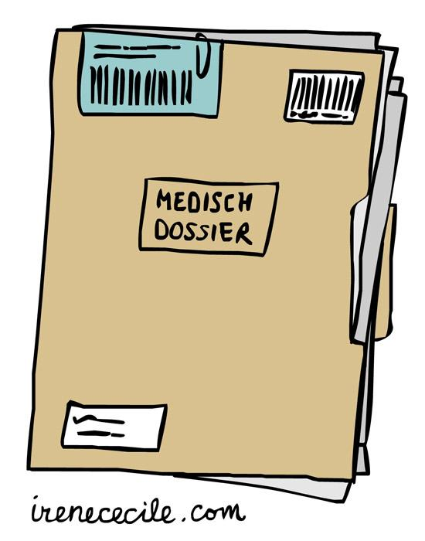
What are the benefits and disadvantages?
There are no benefits for you. Sharing your information will help improve patient care and treatment outcome.
If you do not share your information you will not have disadvantage. You will receive the treatment and care you would normally receive.

Important to know:
- Sharing your information is not required.
- You can always stop sharing your information without having to tell why.
- You can always ask questions.

If you have questions
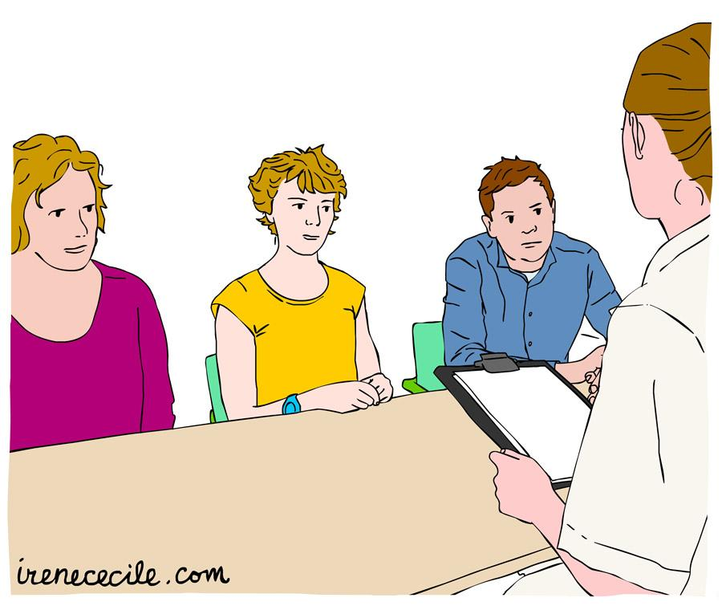
You can ask any questions to your parents. Or you can ask your questions together with your parents to doctor [insert name]. You can reach doctor [insert name] via: [insert information; email or phone number].

