PALAZZO DELLE STELLINE
IEWP MEETING MILAN
23-26 SEPTEMBER 2021

Please fill the following reservation form and send it through e-mail in order to confirm your reservation before August, 30 2021
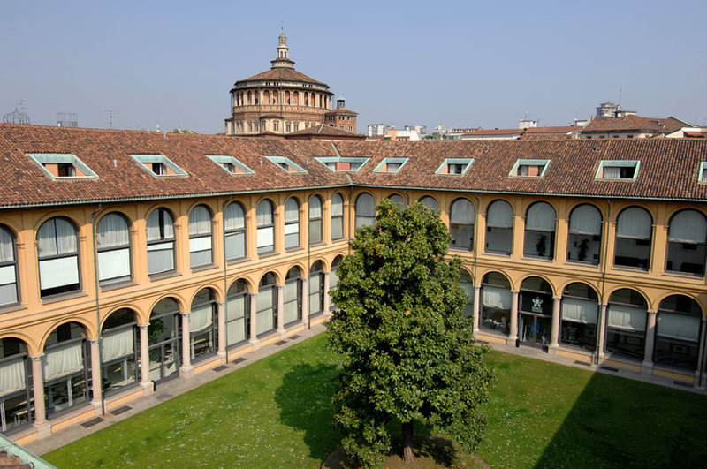
Hotel Palazzo delle Stelline- Milano
Corso Magenta, 61 - 20123 Milano - Italy
Tel. (+39) 02 48 18 431 Fax. (+39) 02 48 19 42 81
www.hotelpalazzostelline.it
email. info@hotelpalazzostelline.it

ROOMS RESERVATION
Please confirm the following reservation:
Arrival date: _______________________________ (Check-in starting from 14.00)
Departure date: _______________________________ (Check-out until 12.00)

N° ______ single room at €. 130,00/night (buffet breakfast included)
N° ______ twin/double room at €. 160,00/night (buffet breakfast included)
N° ______ suite €.190,00/night (buffet breakfast included)

Please note that room rate does not include city tax (€.4,00 per person per night, to be added)

Name and surname:_________________________________________________________________________
Address: ____________________________________________________________________________________
City/Town:__________________________________________________________________________________
Phone number:___________________________ E-mail: ________________________________________
Credit card: _____________________________________________ Expiry date: _____________________
Signature: ___________________________________________________________________________________
Note well: the above-mentioned reservation is guaranteed. The cancellation over the deadline or the no show will involve a 100% charge of the agreed rate for the room. In case you need to amend or cancel the reservation, we kindly ask you to do it within 7 days before your arrival.

Hotel Confirmation:

________________________________________________________________________________________________
(date, stamp, signature)

