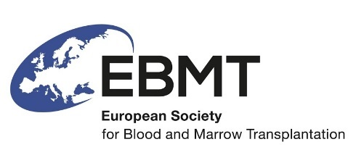

EBMT Nurses Group Research Committee – Research Proposal Form

This form enables your proposal to be registered with the EBMT Nurses Group. Registration will mean that your proposal will be reviewed by the Nurses Group Research Committee (RC). Review by the RC allows the Committee to identify where and in which ways, a research proposal can potentially be supported by the EBMT NG.

The intention of this process is:
- to ensure the proposer(s) of research study ideas retains ownership,
- to encourage nurses to present ideas and aspirations for research within a wider European setting
- to provide specialist support and advice regarding research planning, development and implementation
- to identify areas of interest to EBMT members where collaborative research may be undertaken
- to ensure a comprehensive portfolio of nursing based research within the field of stem cell transplantation
- to ensure that research has the best possible chance of being developed effectively and supported appropriately by EBMT NG.
NB Registration and review in itself does not constitute adoption of the research.

Registration Process
Please complete the form below and email to the Nurses Group Research Committee Chair (Dr Sarah Liptrott) at sarah.liptrott@ieo.it
Please contact the Research Committee if you require help completing this form.

Development Process

- The RC will issue a registration id no. (YY/NNN) and add details of the proposal to the register of proposals.
- The Chair of the RC will forward the synopsis to the other RC members.
- The RC members will consider the proposal and the chair (or representative) will collect comments from the group and summarise in a response to the proposer. The RC members may support the proposal, ask the proposer for clarifications and discuss the proposal further, or reject the proposal. The Chair will provide feedback.
- The RC will send supported proposals to the chair of the EBMT NG and other relevant EBMT NG members for comments and input into the study design, if required.
- The proposer(s) along with one or more members of the RC will form a Protocol Development Group (PDG).
- The RC will request an update from the PDG for each of their meetings, at approximately quarterly intervals.
- The RC NG will report to the main EBMT NG at each of the 6 monthly meetings.
- The PDG will finalise the study proposal outline, which should be sent, before submission, to the RC and EBMT NG for a letter of support.
- Funding issues related to the study should be discussed and verified within the PDG and RC before EMBT NG submissions.
- The RC will provide a summary report of the outcome of all registered ideas in the EBMT NG Annual report and relevant meetings.

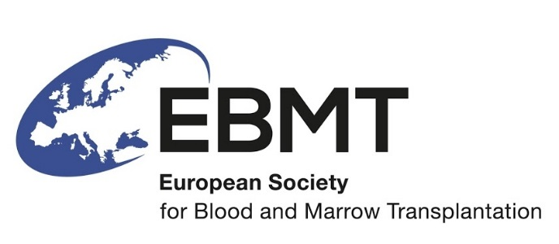 | Date of Request: .. / .. / ..  Date of approval Chair: .. / .. / ..  Please note that approval is necessary before the proposal/feasibility check can be submitted to the Data Office!

Study request proposal
for the
EBMT NG Research Committee

EBMT NG Research Committee chair:
Sarah Liptrott

Title of the study:
(Please do not use more than 15 words)

Principal investigator:
(Name, department, hospital, city, country)

Co-investigator(s):
(Name, department, hospital, city, country)

Introduction:
(State why you think it is necessary to conduct this study in approx. 100 words; list references)

Short description of the study:
(Explain your proposal in approx. 150 words)

Primary objective:
(Describe the primary aim you intend to achieve with this study)

Secondary objectives:

Research design:
(Explain at what time-points during treatment and follow-up data will be asked for, e.g. at diagnosis, at transplant, at 6 months after transplant)
Including: Duration of the study
- Expected start of the study:
- Expected completion of the study:
- Criteria to close patient inclusion: (date inclusion will start, estimation of date inclusion will be closed, length of follow-up, can patients be included retrospectively and if so, define period)

Study Population:
(Expected number of patients, diagnosis, type of transplant, age, period analysed, sampling, stem cell source, inclusion criteria, exclusion criteria)

Data Collection & Statistical Analysis Plan:
(List all research variables to be collected, list all outcome variables to be analysed, and give a brief description of the method of analysis (in collaboration with the EBMT statistician).
All data collection will be performed by the Data Office Leiden according to EBMT guidelines.

Study budget (when applicable):
(In case of funding from outside EBMT, please contact the Data Office Leiden to prepare a budget to negotiate with possible sponsors).
Please note that for any funding for research conducted through or in collaboration with EBMT (whether EBMT is seeking the funding directly or another group is seeking funding for a project involving EBMT) all documentation should be provided to the EBMT NG Research Committee and EBMT NG Board.

Purpose of your study request:
(Paper, Presentation, etc.)

Publication
The EBMT Authorship guidelines apply to this proposal.
Writing Committee
(list all people involved)

Approval

Signature NG President Signature RC chair
name:_______________________ name:_______________________

Signature Head Data Office Signature EBMT statistician
name:_______________________ name:_______________________

Time schedule (to be completed by the data office):
(Planning of preparative work (designing forms), data collections, first interim analysis, completion of study entry, final analysis, report)

Timeline
Preparative work
Inclusion participants
Data collection
Data processing and analysis
Report preparation
Final manuscript and co-authorlist check by Data Office
Total time needed

Please send this form to:
Paul Bosman
Anne Lippinkhof

Data Office Nurses Group
Department of Medical Statistics & Bioinformatics
Postzone S-05-P
LUMC
PO Box 9600
2300 RC Leiden
The Netherlands
Telephone: +31 71 526 5668
Fax nr: +49 711 4900 8723 (fax to e-mail system)
E-mail: p.v.bosman@lumc.nl
a.e.lippinkhof@lumc.nl

